2222222222222222222222222222222EEG LABELING USING OSEL 2.0

- To the left panel of MATLAB open a folder called “Open Signal Explorer and Labeler OSEL”. It’s possible you will have more versions, open the one with the highest number (the latest). You can find it on neurodata common stuff OSEL.
- Click on the “main” function and hit run. This window will appear:

- First you have to load the eeg files. Click on signal → load and choose the files (from 250 Hz folder). After confirmation, this window will appear.
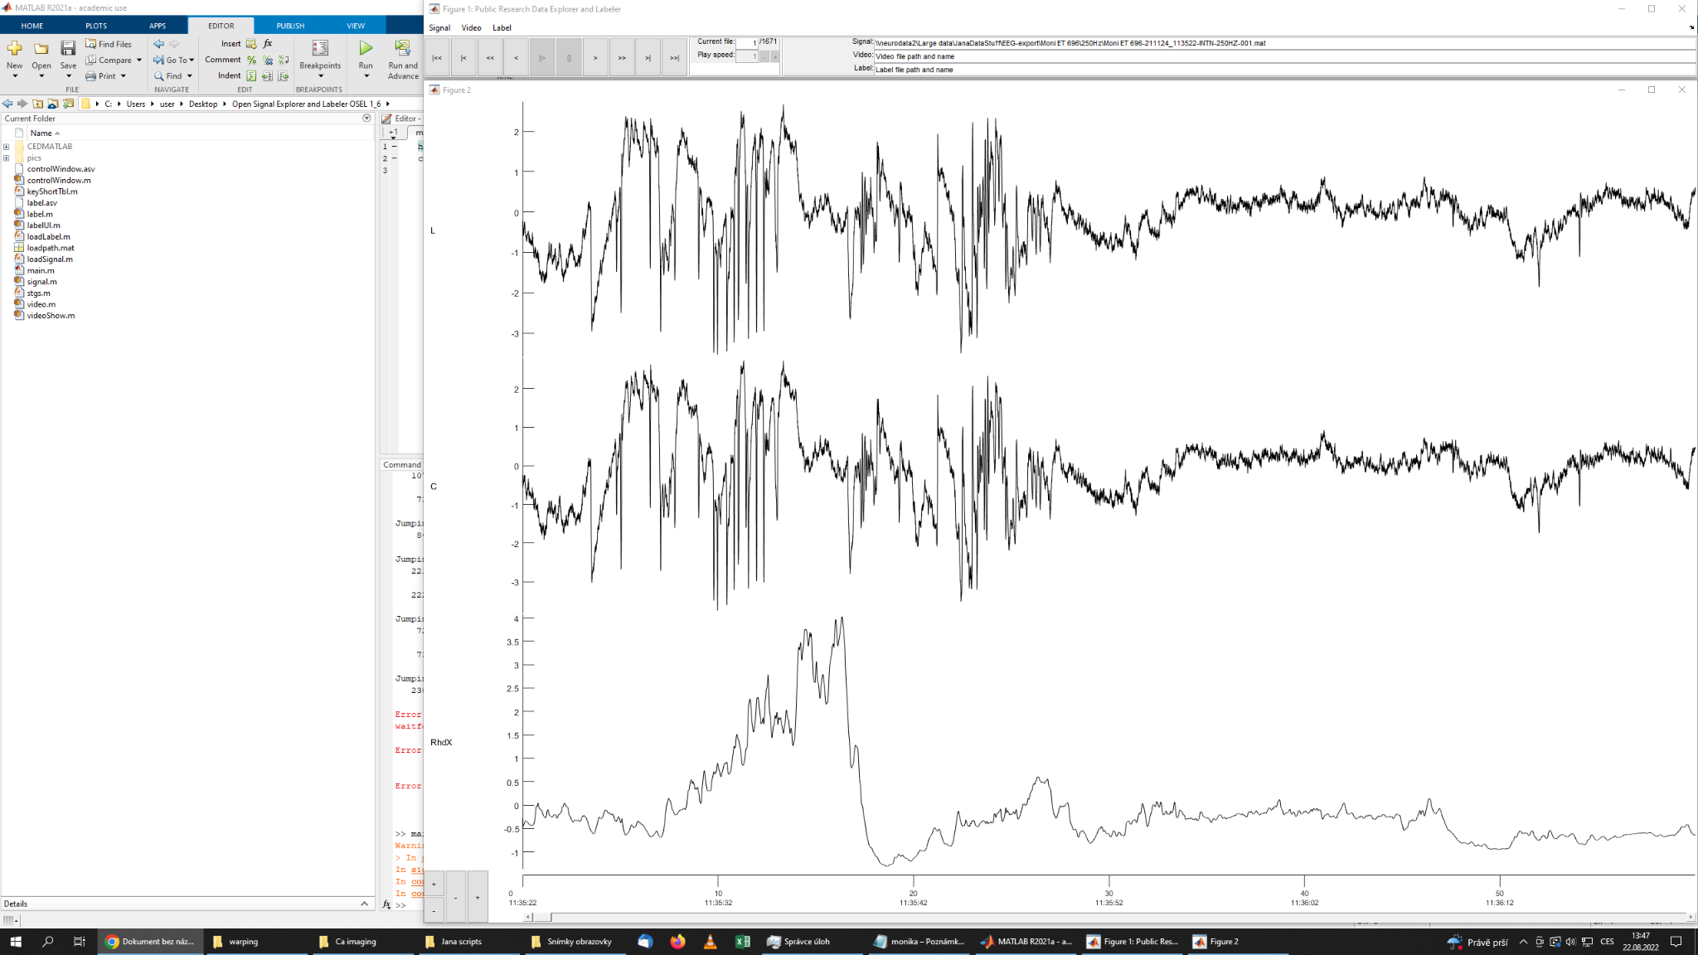
- Now you have to open the label window. Click on Label → label window. In the newly opened window you have to click on Definitions → New (another window) and then Close (also in the new window). This will define your labels.

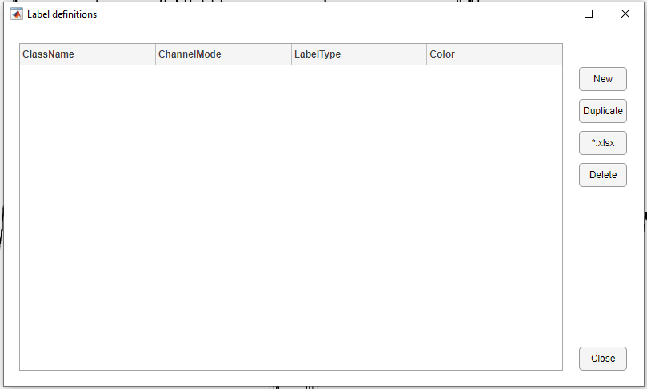
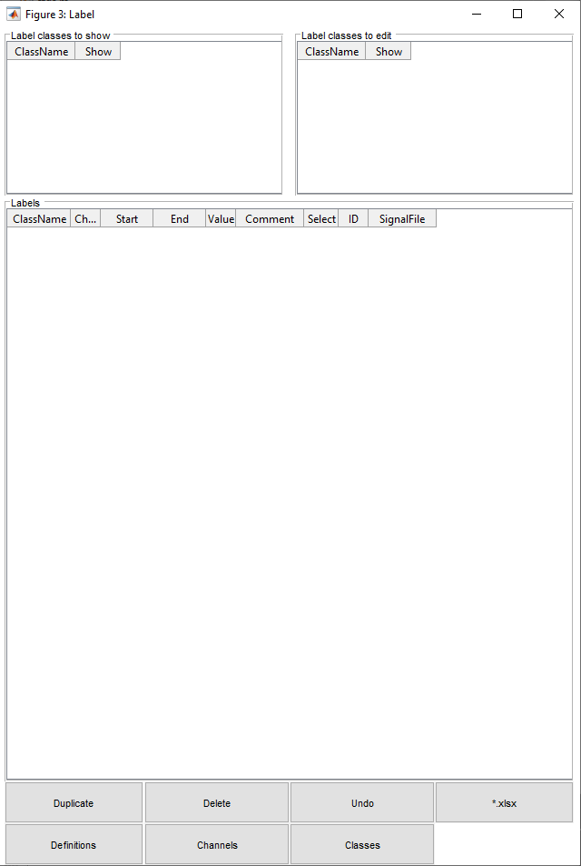

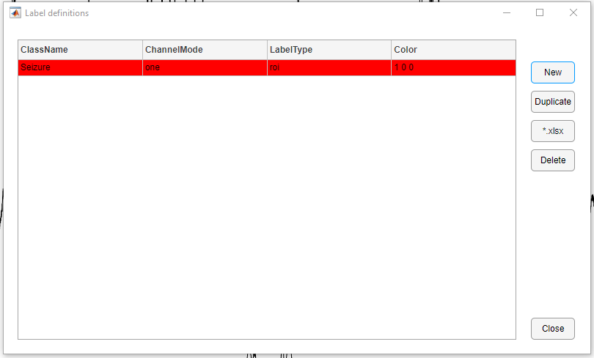

Note: you can change the parameters here after clicking on the coloured parts.

- Now your setup looks like this:
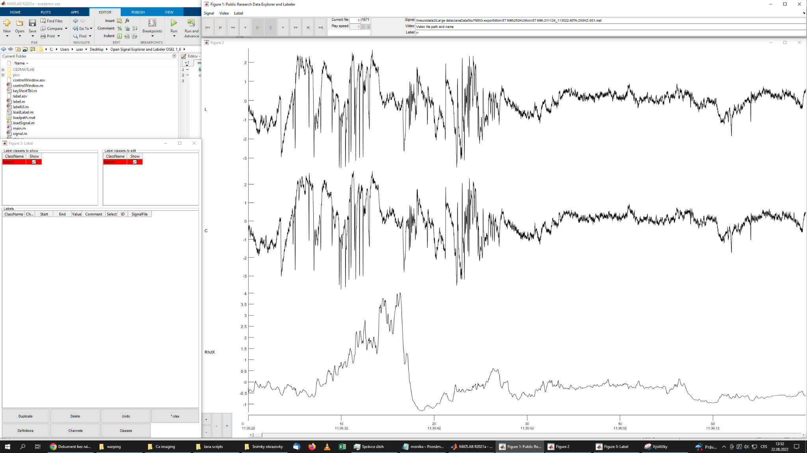
L = eeg from lesion; C = eeg from contralateral hemisphere; RhdX = accelerometer
- You also have to set where to save the labels. Click on Label → Set path and choose a folder (usually the one called Label)
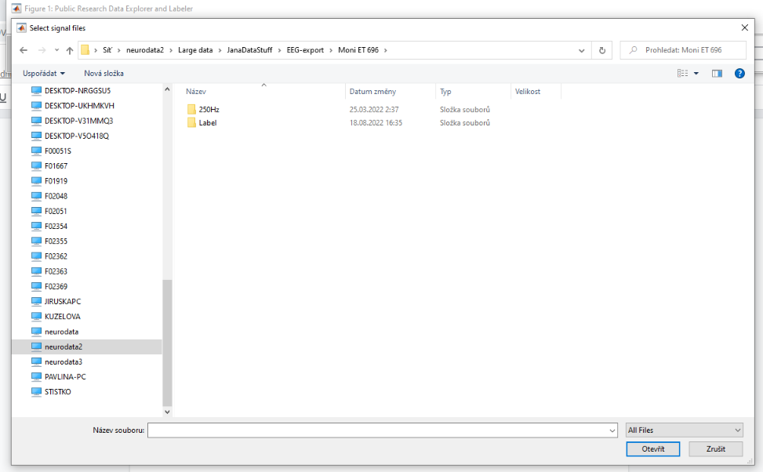

Moving in the eeg

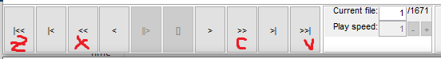

One file (current file) is one hour eeg. In that you can move by using c (forward) and x (backward). Once you jump to the end of the current file you can jump to another file by using v or jump to the previous file by using z (or y with english keyboard). These letters will appear if you hold the mouse over the navigation panel.

Changing scale and amplitude of eeg
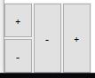
Either you can use these buttons (left ones for amplitude and right ones for scale) or you can hold ctrl while using the scrolling button on mouse for amplitude or hold shift and scroll for scale (more shortcuts later in this manual).

For zooming in in a certain part of an eeg you can hold shift, click with mouse at the start of this part and just move the mouse at the end of that part. After you release the mouse the eeg part will be zoomed in. If you do the same but with ctrl it will zoom out. This can be also used for changing the timescale. Horizontal zoom Ctrl+R, Ctrl+E. Vertical zoom Ctrl+F, Ctrl+D.

If you click on keyShortTbl.m in the left panel of matlab, you will get listed all the shortcuts you can use.

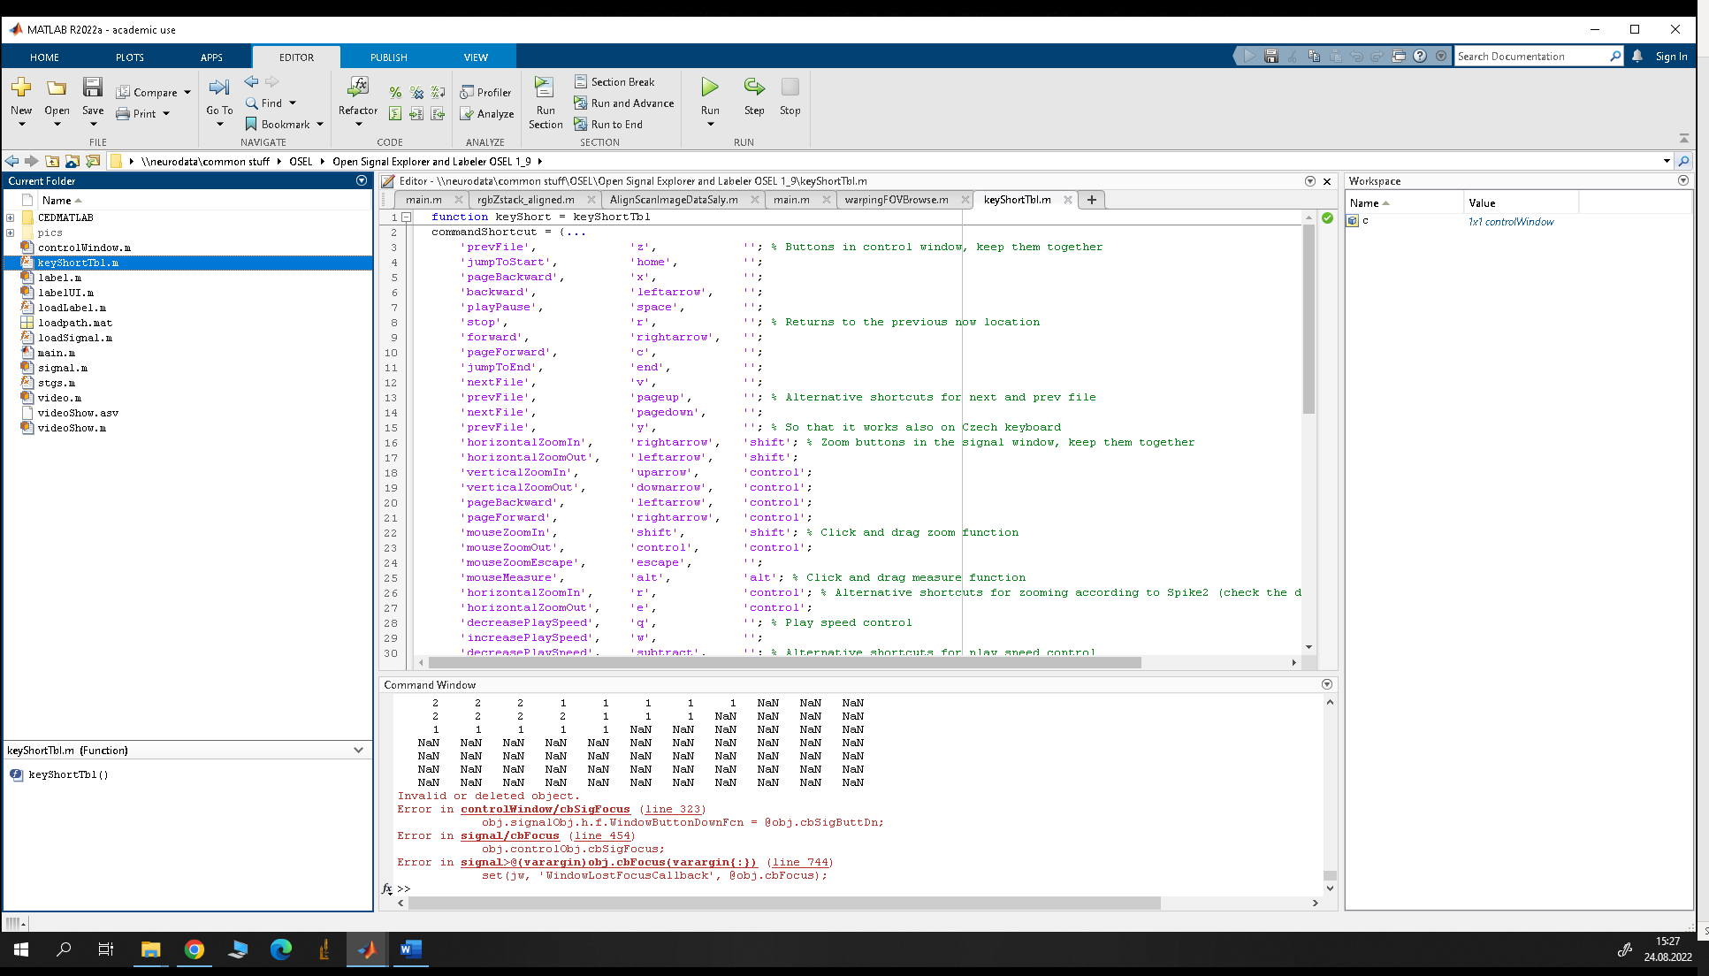

Labeling

We rate eeg labels from 1 (reaaally not a seizure) to 9 (definitely a seizure). If you see an eeg part you would like to label, hold a number you want to assign to that part and click at the start of a seizure (but not on the eeg line) and then click again at the end while still holding the said number (or release and hold the number again and click at the end of your seizure). After releasing the number you will see your label like this:

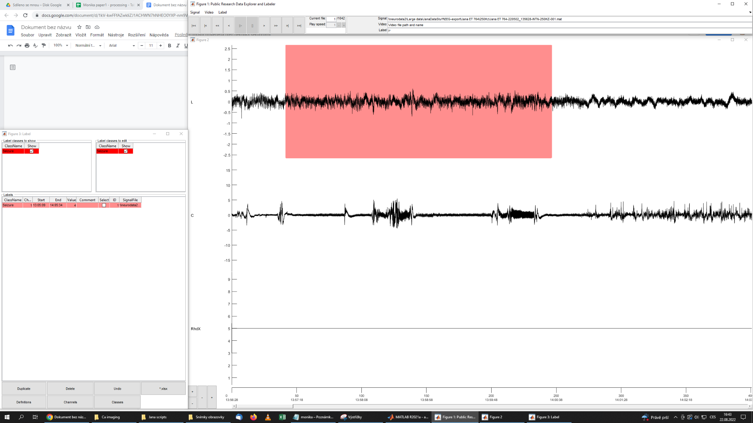
NOTE: THIS IS NOT A SEIZURE!!!

Now you have to save it (ctrl+s) before you jump to another file or your labels will be lost and you’re going to have to go through the files again. All of the files. Again.

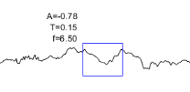
Another useful feature is the chance of measuring some parameters of a certain part of eeg. You hold alt and click and pull a mouse over an area of eeg. It won’t stay fixed, it will just show a preview of parameters while cou change the shape of this blue rectangle.

After you finish you should note down where you stopped (unless you did all the files). After that you can just close all the windows.
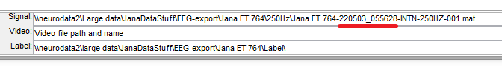
All of the files are named the same except for this part. Note this down so you can start from where you left off.

How to recognize a seizure?

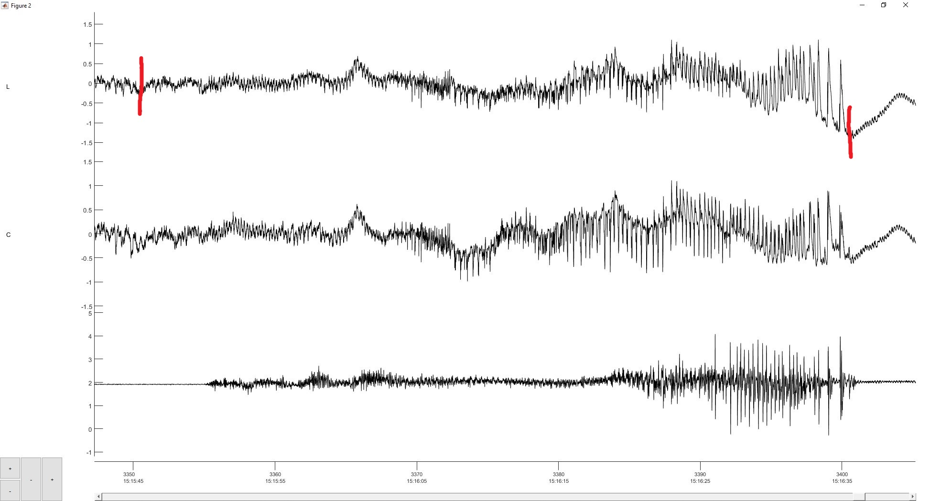
- Contains high-amplitude spikes
- Pattern evolves over the course of the seizure
- May contain slow waves
- At the end the rhythm slows down and amplitude increase up to few mV
- After the last discharge there is usually (not always!) flattening of the EEG containing low amplitude 6 Hz oscillations
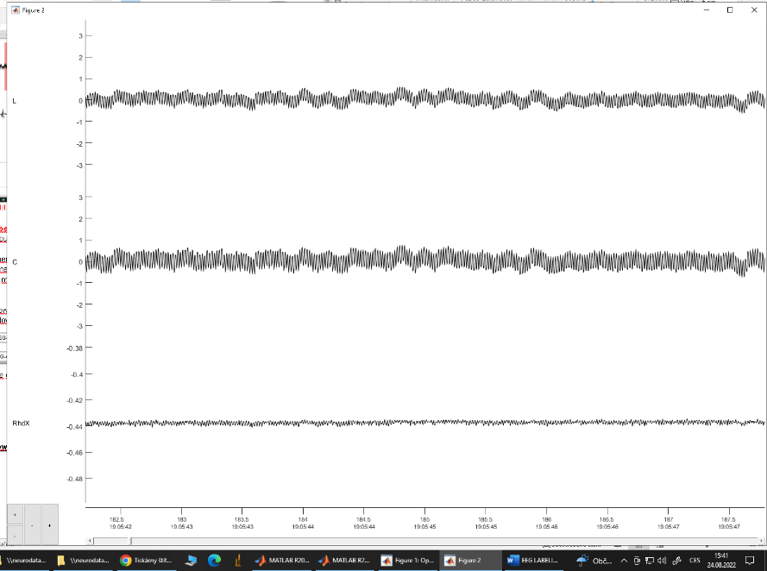
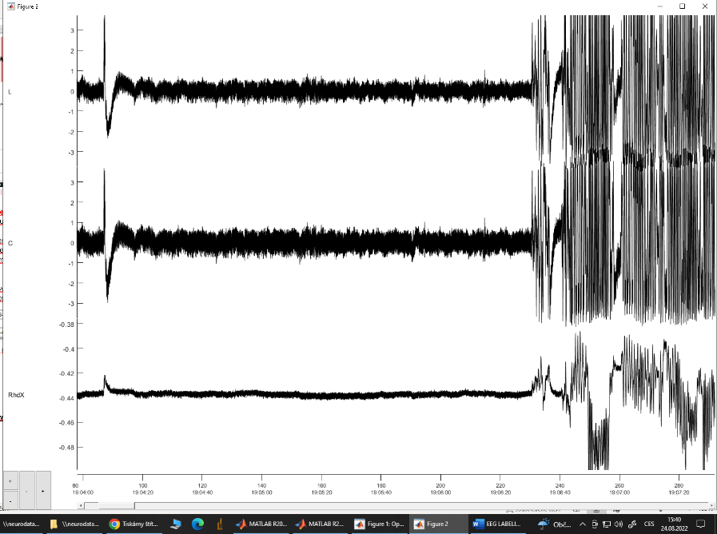
These lines mean the mouse is disconnected from monitoring (usually due to 2p microscop, zoomed-out and zoomed-in):

